

**Department of Computer Science**

**Maqsood Ahmed 38186**

**OOP Quiz: 03**

**Question: 01**

**Source Code:**

public class prob1 {

    public static void main(String args[]) {

        Car car = new Car("BMW", "V5", 2020);

    }

}

class Vehicle {

    public String make;

    public String model;

    Vehicle(String make, String model) {

        this.make = make;

        this.model = model;

    }

}

class Car extends Vehicle {

    public int year;

    Car(String make, String model, int year) {

        super(make, model);

        this.year = year;

    }

}

**Question: 02**

**Source Code:**

public class prob1 {

    public static void main(String args[]) {

        HourlyEmployee emp = new HourlyEmployee("Maqsood", 5720900);

        System.out.println("The salary of " + emp.name " is: " + emp.calculateSalary());

    }

}

abstract class Employee {

    String name;

    int salary;

    abstract int calculateSalary();

}

class HourlyEmployee extends Employee {

    HourlyEmployee(String name, int salary) {

        super.name = name;

        super.salary = salary;

    }

    @Override

    int calculateSalary() {

        return salary;

    }

}

**OUTPUT:**

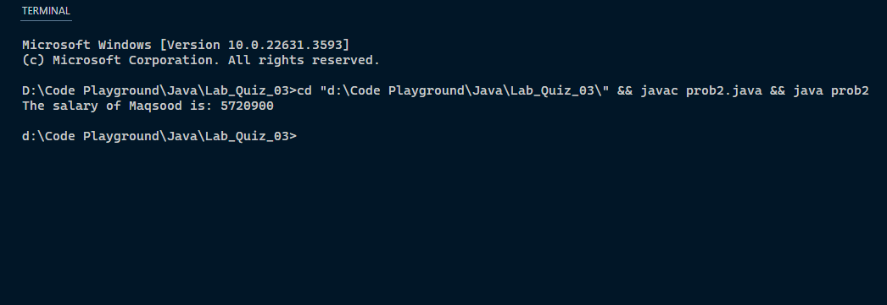

**The End**